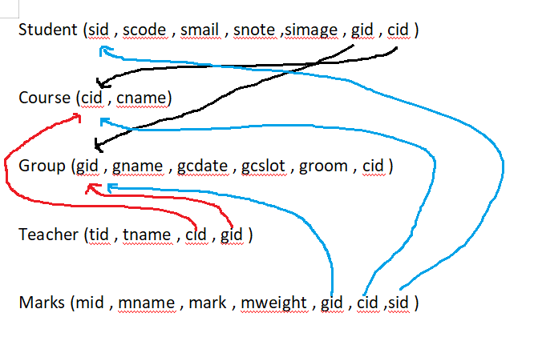

**FOR TEACHER :**

Home page screen

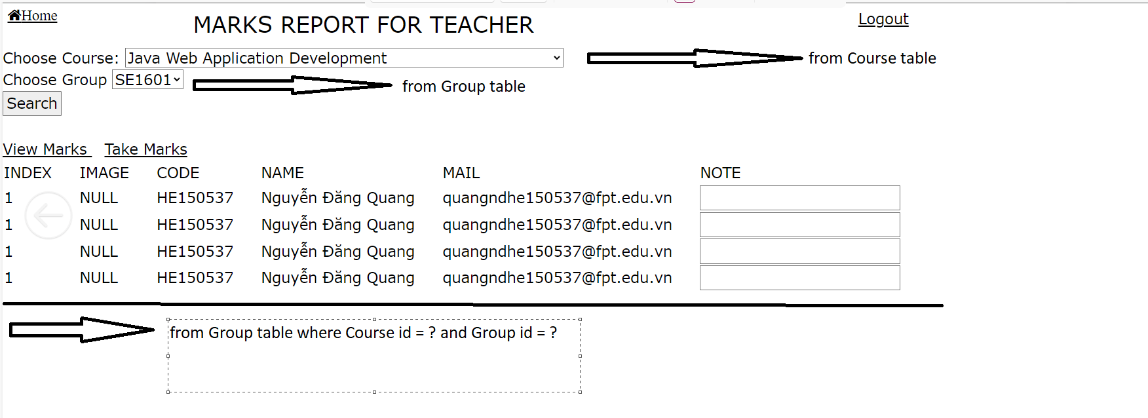

When user click View Marks

View Marks Screen

+)Click Home to forward to Home Screen

+)Click Logout to forward Login Screen

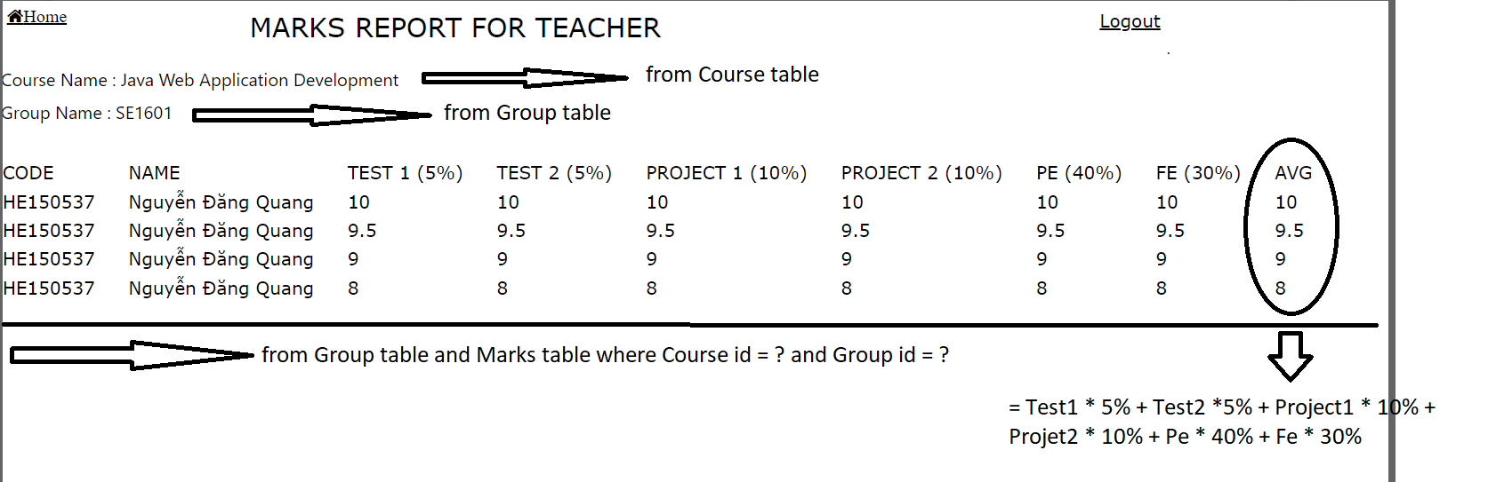

When user click Take Marks

Take Marks Screen

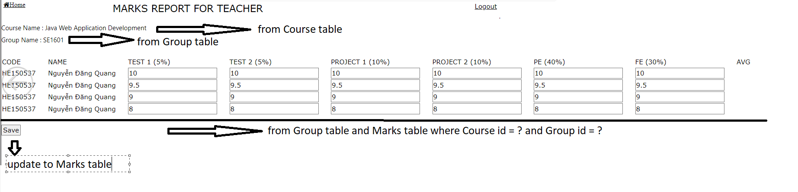

FOR STUDENT :

